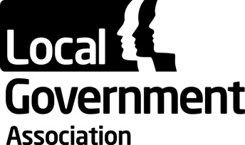 | LGA General Assembly  3 July 2018
LGA Consolidated Financial Statements for the Year to 31 March 2018
Purpose of the Report

To invite the General Assembly to receive the LGA consolidated financial statements for 2017/18.

The LGA’s consolidated financial statements for the year ended 31 March 2018 are included in the LGA Annual Report, enclosed with this agenda. They were reviewed by the Audit Committee on 4 June 2018 and approved by the LGA Leadership Board on 6 June 2018. They have received an unqualified (clean) audit opinion from the external auditors PKF Littlejohn LLP. The auditors will sign the consolidated accounts once all of the financial statements and letters of representation for the individual companies feeding into the consolidated accounts have been signed following their Board meetings in June 2018.

The consolidated financial statements show an operating surplus of £14.498 million (2016/17 £1.019 million surplus). The main cause of the surplus being the net impact of FRS 102 accounting adjustments arising from the £18.994 million unrealised gain (2016/17 £0.548 million unrealised gain) on investment properties, as 18 Smith Square came back into use during the year after development. These valuation gains were increased by ongoing net savings from corporate and ICT services and additional external income contributions to overheads.

The overall pension deficit decreased by £9.491 million to £115.500 million (2016/17 increase by £30.240 million). This valuation has been carried out in line with FRS 102 accounting standards and is therefore subject to market performance on a specific date. The LGA is making additional pension contributions in order to eliminate the deficit over a period of between 15 and 22 years.

Recommendation

That the General Assembly receives the financial statements for the year to 31 March 2018.

Contact officer: | Jonathan Gratte
Position: | Strategic Finance Manager
Phone no: | 0207 187 7309
E-mail: | Jonathan.Gratte@local.gov.uk

